**Theory Of Automata (TOA)**

**(Assignment 02)**



Session (2022-2026)

Program

**BS-Computer Science**

Submitted By:

Student Name: Shaheer Ali Roll Number: 301221044

Supervised By:

Mr. Imran Khan

Lecturer

CS& IT Department

**Hazara University, Mansehra**

**Question No 1:**

Convert the following FA Machine into equivalent Regular Expression using Kleene’s Method. Specify each step clearly.

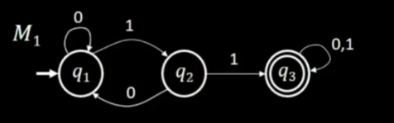

**Answer:**

* States: q1, q2, q3
* Alphabet: {0, 1}
* Transitions:
  + 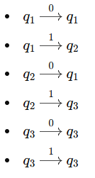

**Steps to convert the FA to a regular expression:**

1. **Initial Regular Expressions:**

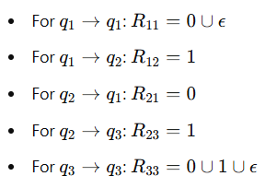

1. **Remove State q2:**

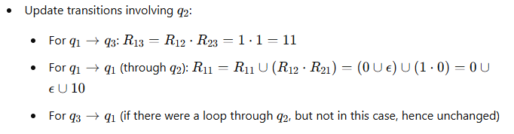

1. **Final expression (removing q1):**

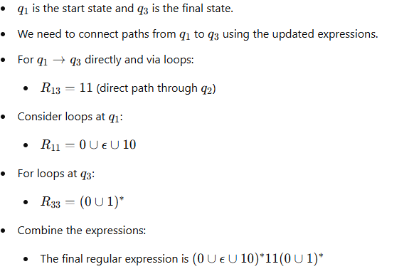

1. **Simplify the regular expression:**



**Thus the equivalent regular expression is:**



**This regular expression represents the language accepted by the give FA using Kleene’s method.**

**Question No 2:**

Using the technique discussed by Martin , Build an FA that accept the following language.

L={w belong to {a,b}*: Length(w) >=2 and second letter of w, from right is a}.

**Answer:**

a

b

a

b

a

b

a,b

**Question No 3:**

Build an FA for the following regular Language L defined over ∑= {a,b}

L= {a, ab, bab, bb}

**Answer:**

For constructing an FA for this language, we need to create states and transitions for each of the strings:

1. **States:**
   * q0 (start state)
   * q1 (accepting state for 'a')
   * q2 (accepting state for 'ab')
   * q3 (intermediate state)
   * q4 (accepting state for 'bab')
   * q5 (accepting state for 'bb')
2. **Transitions:**
   * From **q0**:
     + Read 'a': Go to **q1** (final for 'a')
     + Read 'b': Go to **q3**
   * From **q1**:
     + Read 'b': Go to **q2** (final for 'ab')
   * From **q3**:
     + Read 'a': Go to **q4** (intermediate state)
   * From **q4**:
     + Read 'b': Go to **q2** (final for 'bab')
   * From **q3**:
     + Read 'b': Go to **q5** (final for 'bb')

**Question No 4:**

Give the 5-tuple representation and draw the transition table for the following FA.

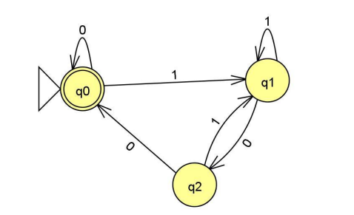

**Answer:**

